Curriculum Vitae (CV) 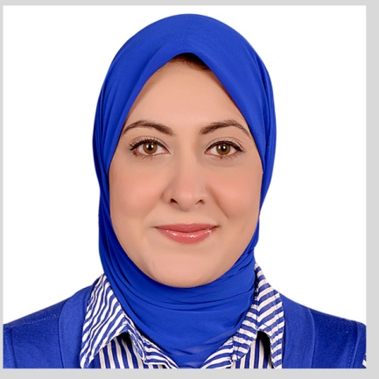

Personal Information

Surname (Family name): Mhmoud.
First/Other names: Amal Mohammed hosni Alameldin mhmoud.
Title: Dr.
Gender: Female.
Address: El zhraa, takseem eltrabishy ,sherkat feryal , borg badary ,Assiut, Egypt.

Nationality: Egyptian.
Place and date of Birth: Libya, 12-10-1983.
Emails: amal.alameldin@yahoo.com .
Amal.alameldin@aun.edu.eg
Telephones: 01026122444(Mobile).
Language skills
Arabic: Native language.
English: Good knowledge (TOEFL).
Computer Skills:
ICDL Certified.

Education
2000 - 2006: M.B.B.Ch (Bachelor of Medicine and Surgery), Faculty of Medicine, Assiut University, Assiut, Egypt (Degree: very good with honor).
2007 - 2008: Training year in the clinical departments of Assiut University Hospital.
2008 - 2011: M.Sc. (Master in clinical pathology), Faculty of Medicine, Assiut University, Assiut, Egypt (Degree: very good).
2012 - 2018: MD (clinical pathology), Faculty of Medicine, Assiut University, Assiut, Egypt.

Employment History
2007 - 2008: Training Physician at Assiut university hospitals, Faculty of Medicine, Assiut University.
2008 - 2011: Resident Physician at Clinical pathology department, Faculty of Medicine, Assiut University.

2011 - 2012: Assistant Lecturer, Clinical pathology department, Faculty of Medicine, South Valley University, Qena, Egypt.
2012 - 2018: Assistant Lecturer, Clinical pathology department, Faculty of Medicine, Assiut University, Egypt.
Now Lecturer, Clinical pathology department, Faculty of Medicine, Assiut University, Egypt
2017 -2019 Doctor at heamatology unit in el-borg lab
2019 doctor at microbiology unit in alfa lab

Training and workshops
-International publication of research from 3-5 May 2014.
-Quality standards in teaching from 14-15 June 2014.
-Research team management from 23-24 December 2013.
-Effective presentation from 22-24 March 2014.
-Time and conference management from 10-11 January 2015.
-Statistical analysis using SPSS 26 January 2013.
-Advanced PowerPoint from 21-24 January 2012.
-6th Annual scientific conference of clinical pathology department 5-7 March 2014.
-5th Alexandria clinical pathology department 3-5 March 2015.
-Iso 15189 in clinical chemistry lab 27 October 2013 south Egypt cancer institute Assiut.
-Teaching methods 19-20 December 2015.
-Methods of assessment 26-27 December 2015.
-New practical application of 8 color flow cytometry 11-12 February 2014 South Egypt cancer institute, Assiut University.
-Total quality management in clinical laboratories 25 November 2015.
-Difficulties and risk management of quality in medical lab 15-16 February 2012.
- 7th Annual scientific conference of clinical pathology department Hurghada 25-28 February 2015.
- 4th Annual conference of clinical pathology department 17-18 February 2009 Assiut University.
-BLS provider 11 June 2017.
-10th Annual scientific conference of clinical pathology department Hurghada 21-24 February 2018.
-Acute abdomen scientific meeting of faculty of medicine 26 December 2015.
-Random review of AUHs mortalities in hot areas a start for correction plane scientific meeting of faculty of medicine 23 January 2016.
-Quality assurance system in clinical microbiology laboratories 17-18 September 2017.
-Workshop on microbiology laboratory techniques for surveillance of healthcare associated infections and antimicrobial resistance 15-17 August 2016.
- 7th Annual scientific conference of clinical pathology department, Assiut University 25-28 February 2015.
- 8th Annual scientific conference of clinical pathology department, Assiut University 16-19 March 2016.
-Implementation of electronic surveillance of healthcare associated infections in intensive care units 19-22 March 2017.
-Implementation of electronic surveillance of surgical site infections in hospitals 23 March 2017.
-28th Annual conference of the Egyptian society of laboratory medicine 8-10 April 2017.
-Workshop of stool preparation and examination 28-30 March 2017.
-7th Alexandria clinical pathology department 7-9 March 2017.
-Workshop on total quality management in clinical laboratories 25 November 2015.
-AUC Specialized certificate in infection control 2018.
- 8th Annual conference of clinical pathology department faculty of medicine ,cairo university 17 march 2018 .
- Workshop on challenges in accreditation of microbiology laboratory on 19-march ,2018
Fellows program in international infection control in school of medicine Louisville USA in 2nd November 2018 .

Publications:
(Different methods in diagnosis of pulmonary and extrapulmonary tuberculosis) in medical journal of Cairo University 20-12-2017.
(Circulating miRNA-21 and miRNA-23a expression signature as potential biomarkers for early detection of non-small-cell lung cancer) in MicroRNA

